Started a project in VS Code title is RAG-ChatBot   
  
**Creating environment**

* python -m venv Chatbot

**activating environment**

* Chatbot\Scripts\activate

**Now created requirements.txt file**   
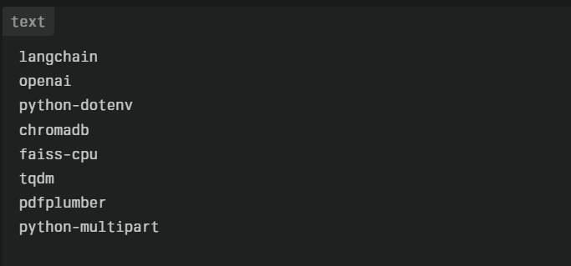

Executed command

* pip install -r requirements.txt

steps to form dynamic upload:

1.imports

2.key load

3.llm , embedding

4.prompt

5.INPUT : upload , query

6.If upload 🡪 Rag

7.button 🡪 ret.invoke🡪 print

Code:  
  
import os

from dotenv import load_dotenv

from langchain_openai import ChatOpenAI, OpenAIEmbeddings

from langchain_community.document_loaders import PyPDFLoader

from langchain_community.vectorstores import Chroma

from langchain.text_splitter import RecursiveCharacterTextSplitter

from langchain.prompts import ChatPromptTemplate

from langchain.chains.combine_documents import create_stuff_documents_chain

from langchain.chains.retrieval import create_retrieval_chain

# 1. Keys & models

# -----------------------------------------------------------

load_dotenv()

OPENAI_API_KEY = os.getenv("OPENAI_API_KEY")

llm = ChatOpenAI(model="gpt-3.5-turbo", api_key=OPENAI_API_KEY)

embeddings = OpenAIEmbeddings(model="text-embedding-3-small",

                              api_key=OPENAI_API_KEY)

# 2. Prompt MUST expose both input vars:  input  and  context

# -----------------------------------------------------------

prompt = ChatPromptTemplate.from_messages([

    ("system",

     "You are an assistant. Use the following context to answer the user.\n"

     "Context:\n{context}"),

    ("user", "{input}")

])

# 3. Ingest document → split → embed

# -----------------------------------------------------------

docs = PyPDFLoader("EswarReddy_FullStack(Resume).pdf").load()

splitter = RecursiveCharacterTextSplitter(chunk_size=300, chunk_overlap=50)

chunks = splitter.split_documents(docs)

vector_db = Chroma.from_documents(chunks, embeddings)

retriever = vector_db.as_retriever()

# 4. Build chains

# -----------------------------------------------------------

combine_docs_chain = create_stuff_documents_chain(llm, prompt)   # needs context

rag_chain          = create_retrieval_chain(retriever,           # retriever FIRST

                                           combine_docs_chain)   # combine-docs SECOND

# 5. Ask a question

query   = "What is the name and mobile number of the person in the resume? and 5+5?"

result  = rag_chain.invoke({"input": query})

print(result["answer"])      # <= only the answer